EX NO: 3

25/08/2021

**SIMPLE SHELL PROGRAMS**

**AIM:**

To execute some simple shell programs.

**PROGRAM:**

**1)Fibonacci program:**

**Source Code:**

#!/bin/bash

a=0

b=1

echo "Enter number of terms:"

read terms

echo "The fibonacci series is:"

for (( i=0; i<terms; i++ ))

do

echo "$a"

c=`expr $a + $b`

a=$b

b=$c

done

**Output:**

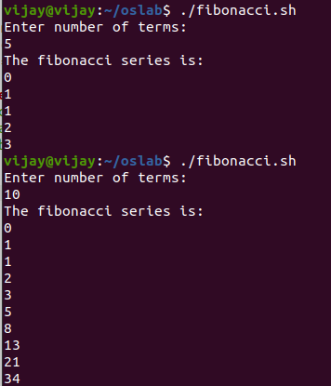

**2)Factorial program:**

**Source Code:**

#!/bin/bash

a=1

echo "Enter the number:"

read number

if [ $number == 0 ]

then

echo "Factorial of 0 is 1"

else

for (( j=2;j<=number;j++ ))

do

a=`expr $a \* $j`

done

echo "The factorial of $number is:$a"

fi

**Output:**

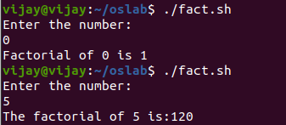

**3)The students attend the sports camp organized by the school. The teacher is required to select students for different games and roles. The students enter inside the room randomly. The teacher gets the details of the student which includes roll no, age, gender, height and weight.   
If the student is a male and has a height less 150 cm then he is selected for kho-kho team.   
If a student has a height more than 170 cm then he/she is selected for basket ball team irrespective of whether the student is a boy or girl.  
If a student is a female and has a height between 160-170 cm she is selected for hand ball team.  
If the students age is less than 12 then they are put into support team.  
Calculate the BMI of the student if he/she is eligible to play the sports. Check whether the BMI score is upto the mark. If the BMI score is not upto the mark put the student in the fitness program for one month and then allow him/her to play.  
The BMI score threshold for girls is 24.  
The BMI score threshold for boys is 25.**

**Source Code:**#!/bin/bash

echo "welcome to the sports camp !!"

echo "Students are asked to fill the following details"

echo ""

echo "Enter your roll number:"

read rollno

echo "Enter your age:"

read age

echo "Enter your gender:"

read gender

echo "Enter your height(in cms):"

read height

echo "Enter your weight(in kgs):"

read weight

t=10000

a=`expr $t \* $weight`

b=`expr $a / $height`

bmi=`expr $b / $height`

echo ""

if [ $age -lt 12 ]

then

echo "You are placed in the support team"

else

if [ $gender == "male" -a $height -lt 150 ]

then

if [ $bmi -lt 25 ]

then

echo "Congrats!! You are selected for kho-kho team"

else

echo "Take fitness program for one month and you can play"

fi

elif [ $height -gt 170 ]

then

if [ $gender == "male" -a $bmi -le 25 ]

then

echo "Congrats!! You are selected for Basketball team"

elif [ $gender == "female" -a $bmi -le 24 ]

then

echo "Congrats!! You are selected for Basketball team"

else

echo "Take fitness program for one month and you can play"

fi

elif [ $gender == "female" -a $height -gt 160 -a $height -le 170 ]

then

if [ $bmi -le 24 ]

then

echo "Congrats!! You are selected for Handball team"

else

echo "Take fitness program for one month and you can play"

fi

else

echo "sorry, there is no sports program available for the above inputs"

fi

fi

**Output:**

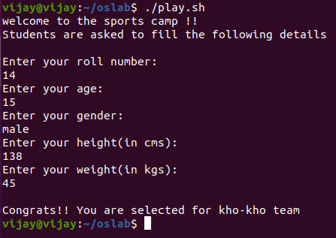

**4)Execute the above scenarios n times using various loops.**

**Using while loop:**

**Source Code:**

#!/bin/bash

echo "welcome to the sports camp !!"

echo "Students are asked to fill the following details"

echo ""

continue="yes"

while [ $continue == "yes" ]

do

echo "Enter your roll number:"

read rollno

echo "Enter your age:"

read age

echo "Enter your gender:"

read gender

echo "Enter your height(in cms):"

read height

echo "Enter your weight(in kgs):"

read weight

t=10000

a=`expr $t \* $weight`

b=`expr $a / $height`

bmi=`expr $b / $height`

echo ""

if [ $age -lt 12 ]

then

echo "You are placed in the support team"

else

if [ $gender == "male" -a $height -lt 150 ]

then

if [ $bmi -lt 25 ]

then

echo "Congrats!! You are selected for kho-kho team"

else

echo "Take fitness program for one month and you can play"

fi

elif [ $height -gt 170 ]

then

if [ $gender == "male" -a $bmi -le 25 ]

then

echo "Congrats!! You are selected for Basketball team"

elif [ $gender == "female" -a $bmi -le 24 ]

then

echo "Congrats!! You are selected for Basketball team"

else

echo "Take fitness program for one month and you can play"

fi

elif [ $gender == "female" -a $height -gt 160 -a $height -le 170 ]

then

if [ $bmi -le 24 ]

then

echo "Congrats!! You are selected for Handball team"

else

echo "Take fitness program for one month and you can play"

fi

else

echo "sorry, there is no sports program available for the above inputs"

fi

fi

echo "Do you want to continue?[yes/no]"

read continue

done

**Output:**

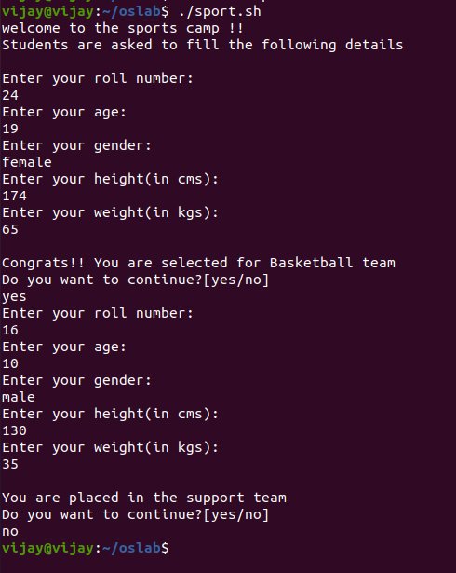

**Using until loop:**

**Source Code:**

#!/bin/bash

echo "welcome to the sports camp !!"

echo "Students are asked to fill the following details"

echo ""

continue="yes"

until [ ! $continue == "yes" ] #for while loop, while [ $continue == "yes" ] is used to execute program.

do

echo "Enter your roll number:"

read rollno

echo "Enter your age:"

read age

echo "Enter your gender:"

read gender

echo "Enter your height(in cms):"

read height

echo "Enter your weight(in kgs):"

read weight

t=10000

a=`expr $t \* $weight`

b=`expr $a / $height`

bmi=`expr $b / $height`

echo ""

if [ $age -lt 12 ]

then

echo "You are placed in the support team"

else

if [ $gender == "male" -a $height -lt 150 ]

then

if [ $bmi -lt 25 ]

then

echo "Congrats!! You are selected for kho-kho team"

else

echo "Take fitness program for one month and you can play"

fi

elif [ $height -gt 170 ]

then

if [ $gender == "male" -a $bmi -le 25 ]

then

echo "Congrats!! You are selected for Basketball team"

elif [ $gender == "female" -a $bmi -le 24 ]

then

echo "Congrats!! You are selected for Basketball team"

else

echo "Take fitness program for one month and you can play"

fi

elif [ $gender == "female" -a $height -gt 160 -a $height -le 170 ]

then

if [ $bmi -le 24 ]

then

echo "Congrats!! You are selected for Handball team"

else

echo "Take fitness program for one month and you can play"

fi

else

echo "sorry, there is no sports program available for the above inputs"

fi

fi

echo "Do you want to continue?[yes/no]"

read continue

done

**Output:**

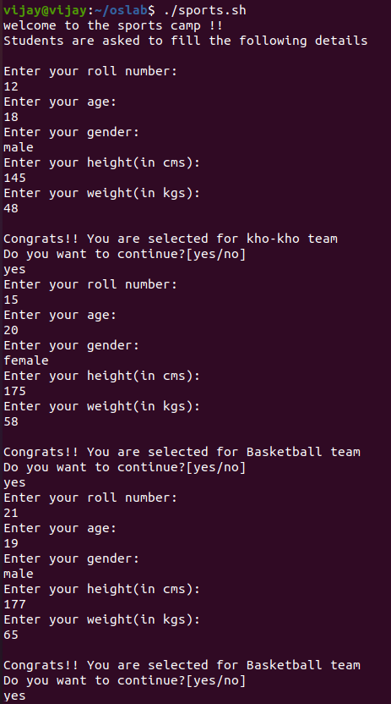

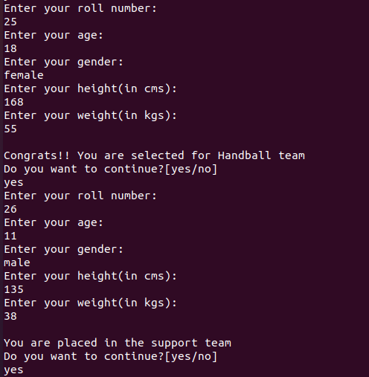

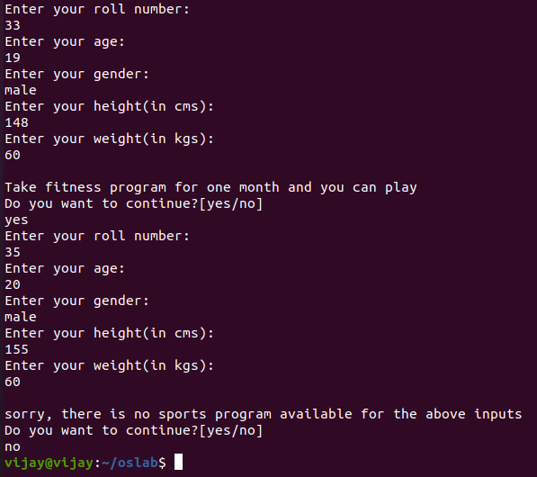

**Using for loop:**

**Source Code:**

#!/bin/bash

echo "welcome to the sports camp !!"

echo "Students are asked to fill the following details"

echo ""

echo "Enter number of students:"

read number

for (( i=0;i<$number;i++ ))

do

echo "Enter your roll number:"

read rollno

echo "Enter your age:"

read age

echo "Enter your gender:"

read gender

echo "Enter your height(in cms):"

read height

echo "Enter your weight(in kgs):"

read weight

t=10000

a=`expr $t \* $weight`

b=`expr $a / $height`

bmi=`expr $b / $height`

echo ""

if [ $age -lt 12 ]

then

echo "You are placed in the support team"

else

if [ $gender == "male" -a $height -lt 150 ]

then

if [ $bmi -lt 25 ]

then

echo "Congrats!! You are selected for kho-kho team"

else

echo "Take fitness program for one month and you can play"

fi

elif [ $height -gt 170 ]

then

if [ $gender == "male" -a $bmi -le 25 ]

then

echo "Congrats!! You are selected for Basketball team"

elif [ $gender == "female" -a $bmi -le 24 ]

then

echo "Congrats!! You are selected for Basketball team"

else

echo "Take fitness program for one month and you can play"

fi

elif [ $gender == "female" -a $height -gt 160 -a $height -le 170 ]

then

if [ $bmi -le 24 ]

then

echo "Congrats!! You are selected for Handball team"

else

echo "Take fitness program for one month and you can play"

fi

else

echo "sorry, there is no sports program available for the above inputs"

fi

fi

done

**Output:**

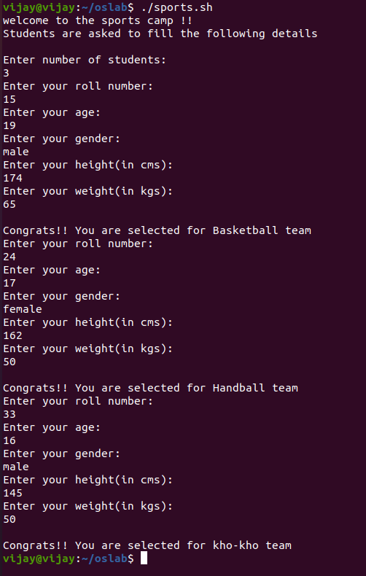

**RESULT:**

The simple shell programs have been executed and the output has been verified.